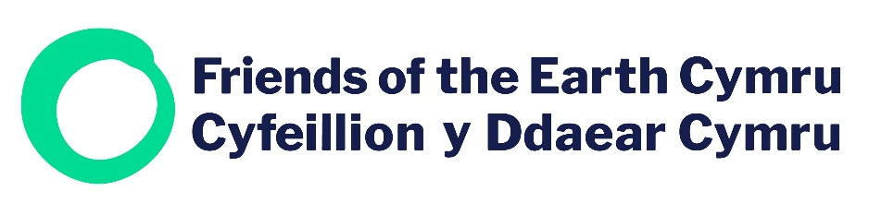
Consultation response

Consultation name | Litter and fly-tipping prevention plan for Wales  https://gov.wales/litter-and-fly-tipping-prevention-plan-wales
Your name | Hannah Morris & Bleddyn Lake
Organisation (if applicable) | Friends of the Earth Cymru
Email Address | cymru@foe.co.uk
Your Address | Friends of the Earth Cymru  ℅ Friends of the Earth England, Wales and Northern Ireland, The Printworks, 139 Clapham Rd, London SW9 0HP

Our Litter & Fly-tipping plan
Question 1: Do you agree litter and fly-tipping should be covered under one plan? If not, please provide a reason for your answer.
Comments: Yes

Question 2: Do you agree with themes we have chosen? Do you think they will help us achieve our ambitions? If no, what other themes do you think need to be included?
Comments: Yes

Question 3: Do you agree with the suggested actions in the waste reduction theme? If not, please provide reasons
Comments: Yes

Question 4: Do you think other actions should be included under the waste reduction theme to achieve the aims of the Plan? If yes, please provide relevant information and evidence.
Comments: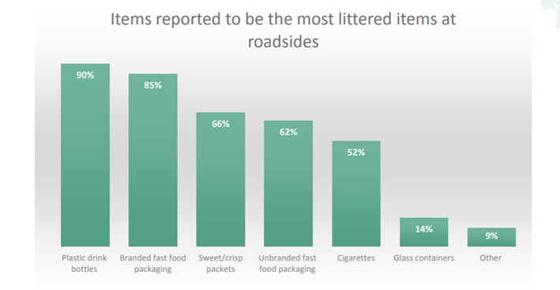

Figure 1: https://www.keepwalestidy.cymru/Handlers/Download.ashx?IDMF=6adb74d9-b76b-4477-88a3-9b04ecb0dbdf
Friends of the Earth Cymru supports adopting a strategic view of each commonly littered item, how and why it is littere, and what the best solution or intervention is for that particular item.
We note that the independent consultancy, Eunomia, has previously conducted research on these items in their report on ‘Options for Extended Producer Responsibility in Wales’ (https://www.eunomia.co.uk/report-category/client/welsh-government/)
Plastic Drink Bottles:
We welcome Welsh Government’s proposal of a Deposit Return Scheme (DRS). The Eunomia report offers substantial evidence to introduce a DRS in Wales. They found that a DRS can reduce littering of beverage containers by 90%, reducing overall litter in Wales by over a third.
Additionally, secondary data analysis of research conducted by Willis et al., (https://www.mdpi.com/2071-1050/11/19/5232) attests to the benefits of installing water refill stations around town and cities to decrease the amount of plastic bottle littering. Their study promotes the success of water refill stations in reducing localised litter and we therefore support the further rolling out of the Refill Wales scheme.
Branded fast food packaging:
Friends of the Earth Cymru have, for example, promoted and supported the idea of a levy or charge on single use cups (coffee and soft drinks), a so called Latte Levy.
Eunomia suggest that:
“such items are estimated to account for over 6% by weight of litter in Wales. It is further estimated that the volume of cups genuinely littered on the ground each year – not placed in a bin, but genuinely littered and subsequently picked up by local authorities – could fill five and a half Olympic swimming pools.”
A Latte Levy on single use takeaway cups in Wales would reduce this source of litter and raise (given a 25p charge) in the order of £97million per year. As it would be a charge rather than a tax, the money would be kept in Wales and could be ring fenced for other waste minimisation and reduction schemes.
We support the proposed Welsh Government ban on single use plastic items such as fast food packaging such as expanded polystyrene trays.
We would also like to see action taken on single portion pots and sachets typically also found in outlets such as fast food establishments. Eunomia also covered this in their Options for Extended Producer Responsibility in Wales report.
They estimated that …
“72 million single serve sachets are placed on the market each year in Wales.
o This results in around 72 tonnes of waste, of which around 71 tonnes are estimated to be captured directly within the residual waste stream and around 1 tonne is believed to be littered on the ground and then picked up by local authorities. This equates to 0.0025% of Welsh municipal waste arisings.
o Given an average weight of 1 gram per empty sachet, 1 tonne of littered sachets would equate to 1 million items.
o Alternatives exist in the form of reusable dispensers or bottles for ketchup, mayonnaise etc.”
We would support the banning of these sachets in Wales or using existing waste hierarchy regulations to promote the use of alternatives in these establishments.

We would also like to see further studies done to investigate whether the idea of car registration numbers printed on takeaway fast food packaging could help reduce litter.
This could perhaps come under the EPR scheme by placing responsibility on business’ to print car registration numbers to trace those who litter the packaging.
Sweet/crisp/chocolate packets and wrappers:
Eunomia estimated that…
“While data is poor, we estimate that around 500 tonnes of such metallised film is consumed in Wales each year, representing 0.015% of MSW arisings, with around 360 tonnes being captured directly in the residual waste stream, and around 140 tonnes being littered and subsequently picked up by local authorities.”
We would encourage an EPR scheme to be extended to include these types of confectionary wrappers as a way to reduce litter.
We would like to suggest increasing collection points to recycle crisp packets. Walkers’ Crisp Recycling Scheme recycled 500,000 crisp packets in just 3 months (https://www.climateaction.org/news/500000-empty-crisp-packets-returned-to-walkers-for-recycling-scheme). We believe that if more collection points were put across Wales as well as awareness campaigns, crisp packet littering would reduce in Wales.
Additionally, an interesting alternative idea that could be looked at would be to develop schemes in Wales which could recycle these products into things such as space blankets for the homeless or even for runners during/after races and for outdoor pursuits enthusiasts. (https://www.bbc.co.uk/news/uk-england-somerset-54888102).
Unbranded fast food packaging:
We would support increased provision and regular emptying of recycling bins in town and city centres if they are proven to be effective and not prone to cross contamination issues.
Cigarettes:
Cigarettes are also one of the most pervasive forms of litter in the world. Plastic filters can take up to 12 years to degrade and cigarette butts leak toxins that contaminate water and harm marine life and the environment.
We welcome Mark Drakeford’s proposal to ban smoking in city and town centres · (https://www.bbc.co.uk/news/uk-wales-politics-46180030). We would support this proposal as it would undoubtedly reduce cigarette related litter. We would also like to see Tobacco companies be included in any EPR scheme.
Glass Containers:
Here we would like to reiterate the need for a deposit return scheme to reduce littering of glass containers (https://www.eunomia.co.uk/report-category/client/welsh-government/)
Marine Litter:
We have also identified different litter items from marine litter, illustrating the need to contextually examine littering in different areas.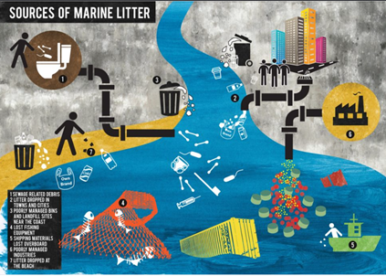

Figure 2: Sources of Marine Litter (https://www.sas.org.uk/wp-content/uploads/SAS-Marine-Litter-Report-Med.pdf)
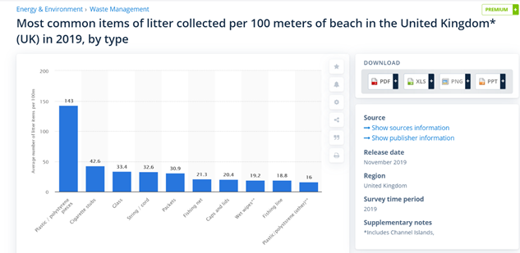
Figure 3: Most common items of litter collected at close proximity to the beach in the UK (https://www.statista.com/statistics/790432/collected-beach-litter-items-united-kingdom/)
Figures 2 and 3 illustrate slight differences between land and marine litter. We support the recommendations from Wales’ Marine Evidence Report: Welsh National Marine Plan (https://gov.wales/sites/default/files/publications/2020-01/welsh-national-marine-plan-update-to-wales-marine-evidence-report-january-2020.pdf). The recommendations of a plastic tax, bottle return scheme, action on single use plastics, and extended producer responsibility as well as Cafes to monitor seafloor littering are all supported by Friends of the Earth Cyrmu.

We note that there are some key differences between more urban litter and that in some coastal areas. We would recommend further study be done on the exact source(s) of specific litter items such as string/cord and develop strategies to effectively deal with these sources. https://publications.jrc.ec.europa.eu/repository/bitstream/JRC108181/technical_report_top_marine_litter_items_eur_29249_en_pdf.pdf
Involving fishing communities will also be key to reducing coastal litter as we can see from many examples around the world both here and abroad (https://www.nationalgeographic.com/science/article/fishermen-kerala-india-recycle-plastic-pollution-culture).
A rising concern for marine litter is the improper disposal of disposable face masks and plastic gloves from the Covid-19 pandemic. Globally, we are using 129 billion face masks and 65 plastic gloves every month, of which a significant amount are being deposited in the environment (https://www.bbc.co.uk/news/av/science-environment-53287940).
Friends of the Earth Cymru would like to highlight the need to increase bins, where littering of masks is common as well as create awareness campaigns.

Question 5: Do you agree with the suggested actions in the waste evidence, monitoring and evaluation theme? If not, please provide reasons.
Comments: Yes

Question 6: Do you think other actions should be included under the waste evidence, monitoring and evaluation theme to achieve the aims of the Plan? If yes, please provide relevant information and evidence.
Comments:

Question 7: Do you agree with the suggested actions in the education and behavioural change theme? If not, please provide reasons.
Comments: Yes

Question 8: Do you think other actions should be included under the education and behavioural change theme to achieve the aims of the Plan? If yes, please provide relevant information and evidence.
Comments:
Friends of the Earth Cymru would like to suggest working through an inclusionary approach to access all populations for waste evidence, monitoring and evaluation. It would be interesting to work with youth groups such as girl guides, scouts, cycling groups etc as anyone and everyone should be a part of the solution. We believe this could help identify which groups are active in particular areas and work with them to identify solutions.
We also welcome Welsh Government’s idea of working with businesses to reduce littering. The success of ‘Love Essex’’ littering campaign worked with local business’ to campaign against littering which achieved a 41% reduction of fast food litter (https://www.litterbins.co.uk/blog/love-essex-hate-litter/). This scheme illustrates the success of business’ and local authorities working together.
If businesses of all sizes kept their own outside areas free from litter it would have an immediate impact both on the amount of litter in an area but also in the public perception of that area which in turn would lead to less littering elsewhere.

Question 9: Do you agree with the suggested actions in the effective enforcement theme? If not, please provide reasons.
Comments: Yes

Question 10: Do you think other actions should be included under the effective enforcement theme to achieve the aims of the Plan? If yes, please provide relevant information and evidence.
Comments: Yes
We have researched into fly-tipping to uncover what is being fly-tipped and why. Research conducted by Hodsman and Williams, 2011 (https://www.icevirtuallibrary.com/doi/pdf/10.1680/muen.900027) illustrates that 56% of fly-tipped household waste comes from large items that you would normally take when moving house (furniture and appliances). They stated that there is a need for greater publicity needed to increase resident awareness of services to discard bulky items. Similarly, Webb et al., 2016 (http://www.tacklingflytipping.com/Documents/NFTPG-Files/Jill-Dando-report-flytipping-research-report.pdf) find that the 2 reasons for fly-tipping are:
- Cost of legitimate disposal
- Availability of waste disposal sites and inadequate waste collection arrangements
To overcome these incentives to fly-tip, Friends of the Earth Cymru would like to suggest using the money from the ‘Latte Levy’or from the Landfill Tax to make council bulky waste collection services free of charge once again for residents who are moving house or simply have bulky items to dispose of. This would immediately remove one of the reasons people give for fly-tipping.

Question 11: Do you agree with the suggested actions in the efficient operational delivery theme? If not, please provide reasons.
Comments: Yes

Question 12: Do you think other actions should be included under the efficient operational delivery theme to achieve the aims of the Plan? If yes, please provide relevant information and evidence.
Comments: Yes
Depending on the type of container used for household recycling, if it is not secured against the weather (or birds for example), many items can become dispersed in the local area on ‘bin day’ so leading to lots of extra litter on our streets. Friends of the Earth Cymru would like to reiterate the need for recycling containers to be secure on collection days.
We support the standardisation of recycling collection methods and adoption of best practice schemes across Wales (such as Pembrokeshire https://www.pembrokeshire.gov.uk/newsroom/its-official-pembrokeshire-is-best-at-recycling-in-wales ) and would recommend again the creation of a new information hub or one-stop-shop for all waste related issues in Wales such as re-use, recycling, food waste, composting, bulky waste collection etc rather than have different organisations and different websites hosting this information. It would surely make sense for all of this information to be accessible in one location (and then via links to individual organisations, companies and local authorities where applicable) to prevent the need to try to find different bits of information on different websites.

Question 13: Our Litter & Fly-tipping Prevention Plan includes a number of actions. Which ones do you think should be a priority? Please give reasons.
Comments:
- Deposit Return Scheme
We strongly believe that a Deposit Return Scheme in Wales will be an extremely beneficial scheme that drastically reduces littering in the county. Evidence from the Eunomia Report (https://www.eunomia.co.uk/report-category/client/welsh-government/) exemplifies the benefits of this scheme in reducing littering of deposit-bearing beverage containers by 90%.
- Extender Producer Responsibility(EPR)
Friends of the Earth Cymru would also like to support the idea of EPR in Wales. It is widely recognised that EPR is a positive step forward within the transition to a more sustainable world. Through EPR, producers become responsible for their post consumer products thus encouraging alternative material use and better product design. This increases recycling rates and decreases waste sent to landfill and incinerators and also by extension reduces litter (https://www.britannica.com/topic/extended-producer-responsibility).
- Using money from Latte Levy or Landfill Tax for free council services to dispose bulky items that are fly-tipped
We believe that in order to successfully implement council services to collect bulky household waste (that would normally be fly-tipped), Welsh Government could support these to become free of charge by using the money raised from a Late Levy or from the Landfill Tax scheme.

Welsh language questions

We would like to know your views on the potential impacts our Litter & Fly-tipping Prevention Plan would have on the Welsh language, specifically on opportunities for people to use Welsh and on treating the Welsh language no less favourably than English.

Question 14: What effects do you think there would be? How could positive effects could be increased, or negative effects be mitigated?
Comments:

Question 15: Please also explain how you believe the proposed Litter & Fly-tipping Prevention Plan could be formulated or changed so as to have positive effects, or increased positive effects, on opportunities for people to use the Welsh language and on treating the Welsh language no less favourably than the English language, and no adverse effects on opportunities for people to use the Welsh language and on treating the Welsh language no less favourably than the English language.

Comments:

Other comments

Question 16: We have asked a number of specific questions. If you have any related issues which we have not specifically addressed, please use this space to report them:
Comments:

Responses to consultations are likely to be made public,
on the internet or in a report. If you would prefer your response
to remain anonymous, please tick here:

