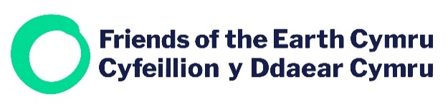

To Welsh Broadcasters

Friends of the Earth Cymru call for televised election climate action debate

The Senedd elections are fast approaching, and public and political awareness of the need to act on climate change is at an all-time high.

Given the necessary COVID-19 restrictions there are fewer opportunities for open public debates during this election campaign, for example through community hustings and canvassing, which makes the role of broadcasters and provision of online and TV content all the more crucial.

Friends of the Earth Cymru would like to request that the main broadcasters organise a special televised climate emergency debate for the leaders of the main political parties in Wales as part of the Senedd election coverage.

In 2018 the Intergovernmental Panel on Climate Change (IPCC) said we have until 2030 to act decisively if we are to have any chance of preventing catastrophic runaway climate change. We are now 3 years closer to 2030.

The next Senedd term is critical for deciding the actions Wales must take to reach our climate emissions reduction targets and play our part in global efforts to tackle climate change.

These Senedd elections mark the first time 16 and 17 year olds can vote for Members of the Senedd. With climate change, the biodiversity crisis and environmental issues in general being of particular concern to younger people, the stance of political parties in Wales on the most serious and pressing issue of our times is of paramount importance.

We would therefore request that television channels in Wales host a televised debate by party leaders in the run up to the Senedd elections, to discuss Wales’ contributions to tackling the climate emergency, and to inform voters of actions that parties will commit themselves to should they be elected in May 2021.

Yours sincerely

Haf Elgar
Director
Friends of Earth Cymru

