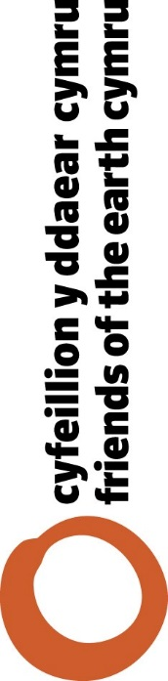

Cwestiynau Cyfeillion y Ddaear Cymru i ymgeisyddion

Ar gyfer yr ymgyrch etholiad, rydyn ni wedi paratoi rhai cwestiynau y gallwch holi ymgeisyddion – ar sail y blaenoriaethau yr hoffen ni iddyn nhw ymrwymo i er mwyn gwneud Cymru yn wlad cynaliadwy i genedlaethau’r dyfodol.

- Will you commit to becoming a fossil free council by 2025?

- Do you support divesting Local Authority pension funds from fossil fuel companies?

- Would you agree to introduce carbon assessments of local authority budgets and major projects, and introduce a 5 year carbon budget?

- Are you prepared to utilise funding schemes and borrowing powers to develop a programme to make cold homes energy efficient?

- Will you support and implement an ambitious programme of solar panels or other suitable renewable energy systems on all suitable schools and public buildings?

- Can you commit to phasing out non-recyclable plastics and promoting reusable alternatives within public buildings and events?

- Would you be prepared to work with local take away outlets to ban polystyrene and other non recyclable food containers?

- Will you support a requirement for electric car charging points to be available at all suitable public buildings and car parks, and as part of new major developments and redevelopments?

- Will you work towards becoming a Bee Friendly Council under the new Welsh Government Bee Friendly scheme?

- Do you agree that the monitoring of air quality should increase, particularly around schools and residential areas, and that where necessary clean air zones to improve pollution hotspots should be set up?

www.foe.cymu
@foecymrucydd
/foecymrucydd
cymru@foe.co.uk

